**Kistler Experiments 13 February**

Note: Don’t mind the “Position 1-5” etc. Position 1 is the only one I’ve used for comparison in following experiments

**Setup info:**

Kistler 9232A calibrated for +- 300 pC/microstrain

Beam material- high carbon steel-ground flat stock from Radionics. Previous tests had used low-carbon steel.

Kistler tightened with analog torque wrench at 10 Nm (+- 0.5Nm acceptable). <Ask Natalia for datasheet> Hysteresis was exhibited beforehand- this measure fixed it.

<Get name of Kistler daq system. Manually recorded measurements shown here>

Applied weights to end of beam- take to be a point load at point 20mm from end.

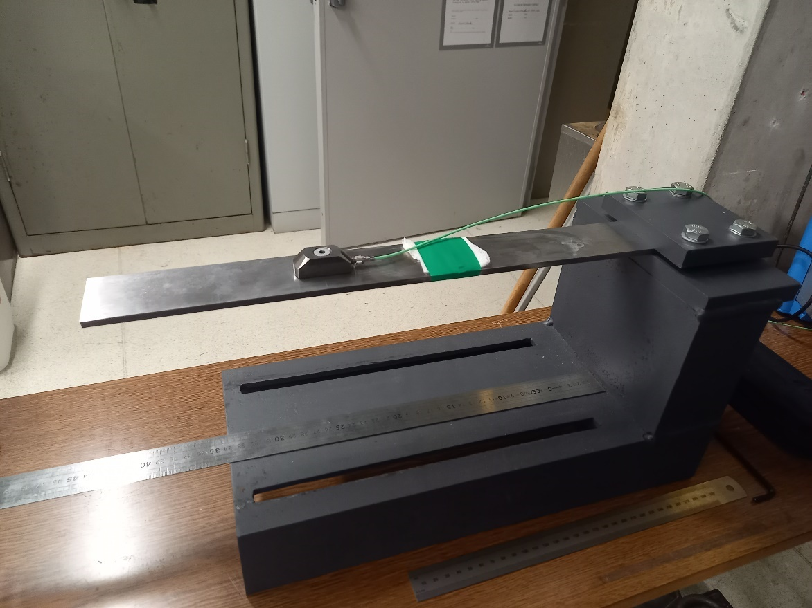

Figure 1. Kistler clamped in the test rig

**Part 1- Kistler on 25mm beam**

Varied the clamped position

Changing this (i.e. changing distances A and B) made no difference to Kistler strain readings

Flipping the beam around (i.e. changing C) did affect readings. The closer it was to end of beam, the less strain was visible.

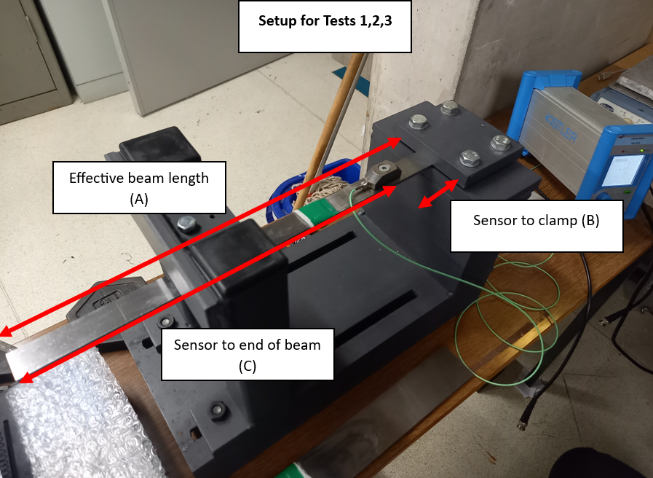

Figure 2: Setup for positions 1, 2 and 3

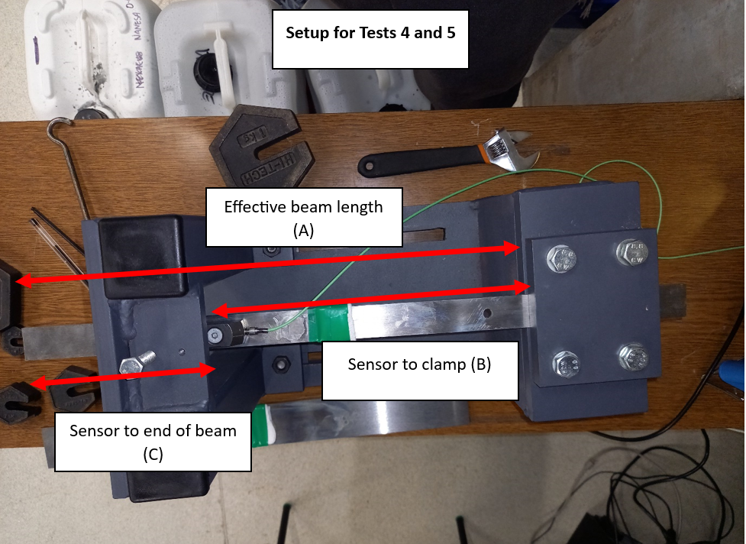Figure 3. Setup for positions 4 and 5

|  |  |  |  |  |  |
| --- | --- | --- | --- | --- | --- |
| **Position** | **1** | **2** | **3** | **4** | **5** |
| A- Effective beam length (mm) | 415 | 445 | 477 | 415 | 445 |
| B- Distance from clamp to sensor centre (mm) | 62 | 90 | 110 | 265 | 294 |
| C- Distance from sensor centre to end (mm) | 355 | 355 | 355 | 150 | 150 |

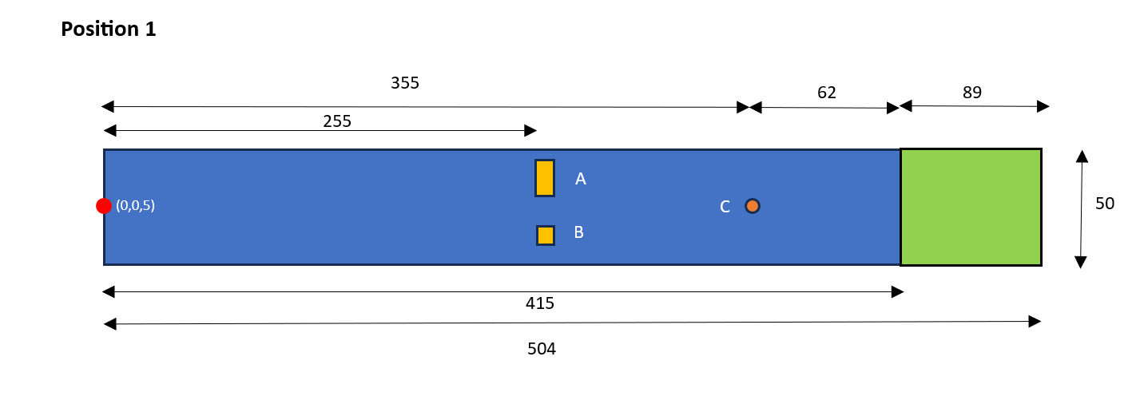Table 1. Beam dimensions for the different positions

Figure 4- Position 1

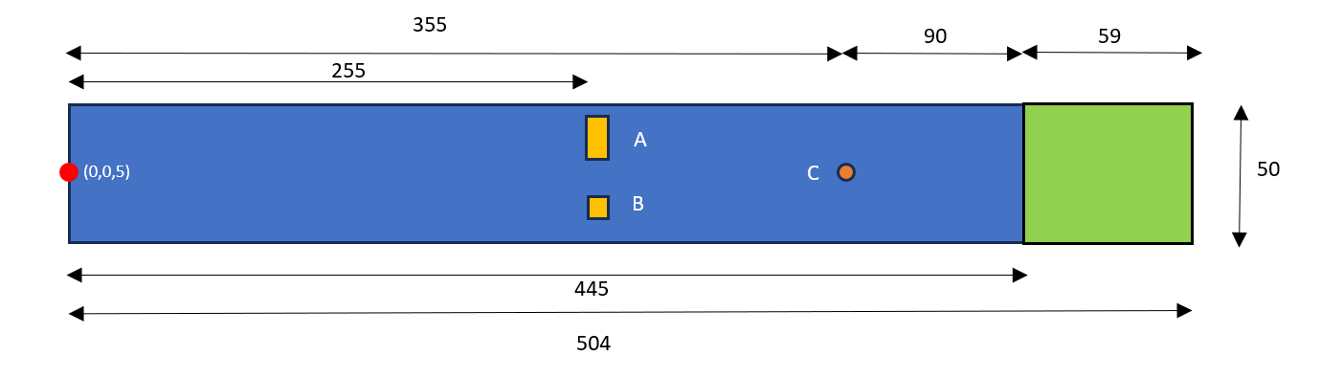

Figure 5- Position 2

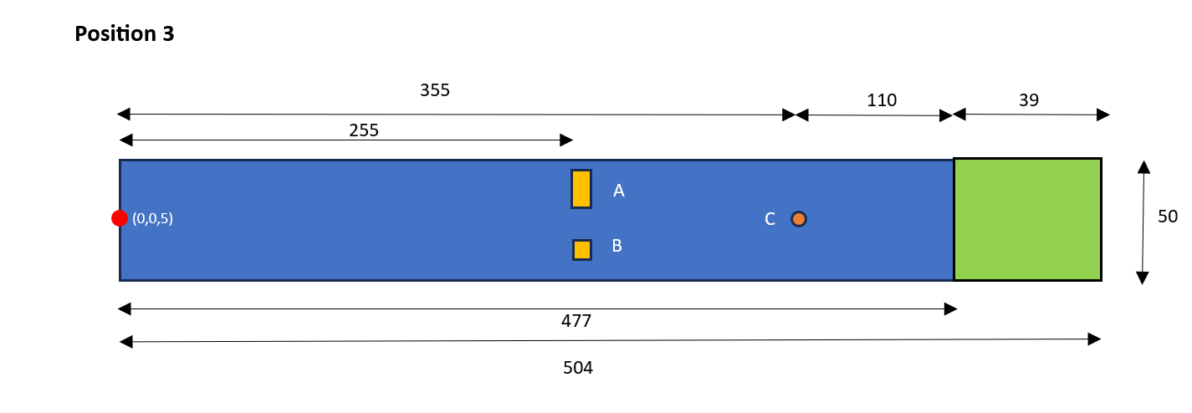

Figure 6- Position 3

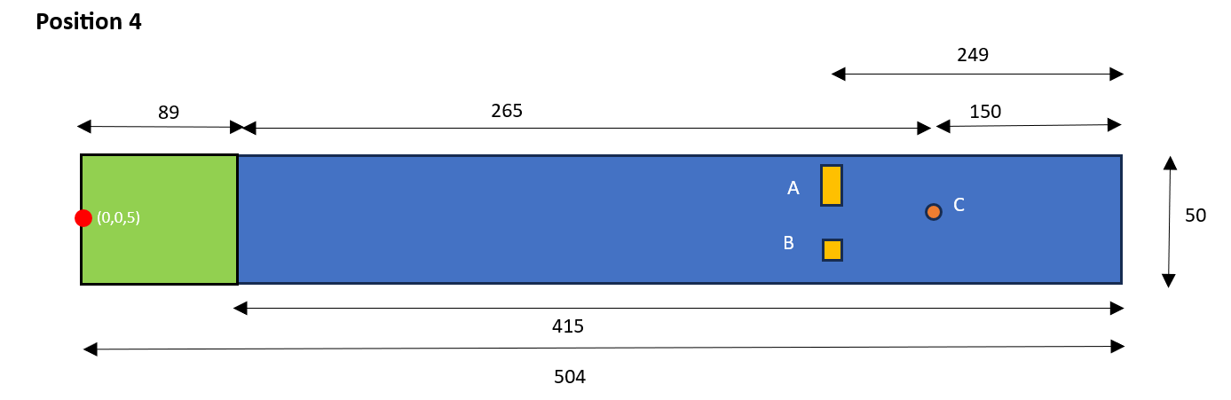

Figure 7- Position 4

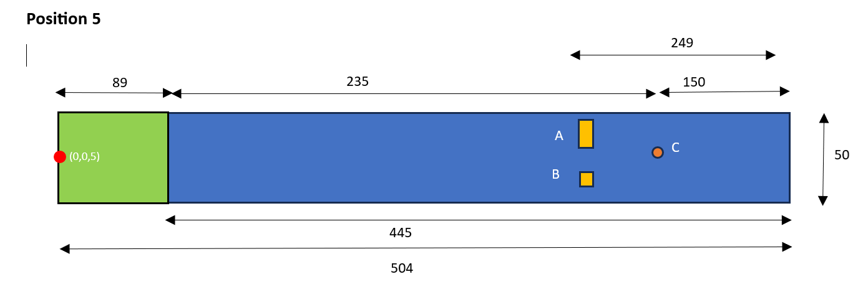

Figure 8- Position 5

Figure 9. Kistler results for positions 1-5

**Part 2: 50mm beam**

Repeated tests at positions 1-3 but with 50mm beam this time

Slightly lower strain shown by 50mm beam

Figure 10. Comparison of Kistler results for 25mm and 50mm beams

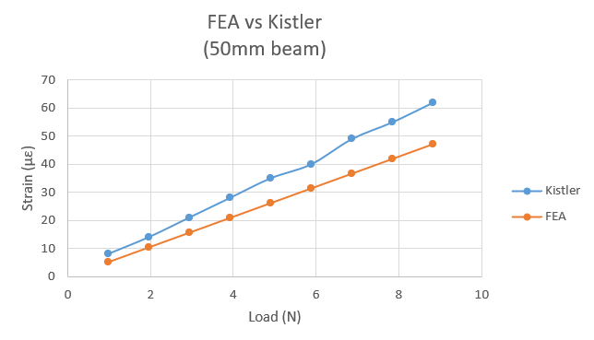

Figure 11. FEA vs Kistler comparison for 50mm beam (position 1)

|  |  |  |  |  |  |
| --- | --- | --- | --- | --- | --- |
| **Load (g)** | **Load (N)** | **Kistler (µε)** | **FEA (µε)** | **Difference  (µε)** | **Difference (%)** |
| 100 | 0.981 | 8 | 7.6 | -0.4 | -5% |
| 200 | 1.962 | 14 | 15.0 | 1.0 | 7% |
| 300 | 2.943 | 21 | 22.5 | 1.5 | 7% |
| 400 | 3.924 | 28 | 29.9 | 1.9 | 7% |
| 500 | 4.905 | 35 | 37.3 | 2.3 | 7% |
| 600 | 5.886 | 40 | 44.7 | 4.7 | 12% |
| 700 | 6.867 | 49 | 52.2 | 3.2 | 6% |
| 800 | 7.848 | 55 | 59.6 | 4.6 | 8% |
| 900 | 8.829 | 62 | 67.0 | 5.0 | 8% |

Table 2. Comparison of FEA and Kistler results for 50mm beam (Conclusions and 25mm beam results in “21.02.24 report”)